Kaouther Abid Challenge 05: Matplotlib Unit

Pymaceuticals Inc.

Analysis:

Summary Statistics:

* the number of mice: 248

|  |  |  |  |  |  |
| --- | --- | --- | --- | --- | --- |
| **Drug Regimen** | **Mean Tumor Volume** | **Median Tumor Volume** | **Tumor Volume Variance** | **Tumor Volume Std. Dev.** | **Tumor Volume Std. Err.** |
| **Capomulin** | 40.675741 | 41.557809 | 24.947764 | 4.994774 | 0.329346 |
| **Ceftamin** | 52.591172 | 51.776157 | 39.290177 | 6.268188 | 0.469821 |
| **Infubinol** | 52.884795 | 51.820584 | 43.128684 | 6.567243 | 0.492236 |
| **Ketapril** | 55.235638 | 53.698743 | 68.553577 | 8.279709 | 0.603860 |
| **Naftisol** | 54.331565 | 52.509285 | 66.173479 | 8.134708 | 0.596466 |
| **Placebo** | 54.033581 | 52.288934 | 61.168083 | 7.821003 | 0.581331 |
| **Propriva** | 52.320930 | 50.446266 | 43.852013 | 6.622085 | 0.544332 |
| **Ramicane** | 40.216745 | 40.673236 | 23.486704 | 4.846308 | 0.320955 |
| **Stelasyn** | 54.233149 | 52.431737 | 59.450562 | 7.710419 | 0.573111 |
| **Zoniferol** | 53.236507 | 51.818479 | 48.533355 | 6.966589 | 0.516398 |

**Tumor Volume Overview:**

* **Capomulin** and **Ramicane** have the smallest mean tumor volumes, approximately **40.68** and **40.22**, respectively, suggesting these two regimens may be the most effective at reducing tumor size.
* **Ketapril**, **Naftisol**, **Placebo**, and **Stelasyn** all have higher mean tumor volumes, ranging from **52.33** to **55.24**, indicating a less pronounced effect in controlling tumor growth.
* **Infubinol**, **Ceftamin**, and **Zoniferol** also show similar trends, with mean tumor volumes around **52.88**, **52.59**, and **53.24**, respectively.

**Variance & Standard Deviation:**

* **Ketapril** and **Naftisol** show the highest variance and standard deviation (68.55 and 66.17 for variance), which suggests greater variability in the tumor volume response among mice treated with these drugs.
* **Capomulin** and **Ramicane** show lower variance (24.95 and 23.49), which implies that their effects are more consistent and reliable across the subjects.

**Standard Error:**

* The **Standard Error** (indicating the precision of the mean tumor volume estimate) is fairly low across all drug regimens, with **Capomulin** (0.33) and **Ramicane** (0.32) having the lowest, suggesting more accurate estimates of tumor volume for these drugs. In contrast, **Ketapril** (0.60) has the highest standard error, meaning its tumor volume estimate is less precise.

**Summary:**

* **Capomulin** and **Ramicane** stand out as the most effective treatments with the lowest mean tumor volume and minimal variance, suggesting they are both potent and reliable.
* **Ketapril** and **Naftisol** have the highest tumor volumes and variability, suggesting they might be less effective.
* The **Placebo** group shows a mean tumor volume similar to that of the other drug treatments, indicating it may not significantly differ in efficacy compared to certain treatments like **Ceftamin** and **Infubinol**.

In conclusion, **Capomulin** and **Ramicane** appear to be the most promising drug regimens, showing consistent and significant tumor size reduction.

**Quartiles, Outliers and Boxplots:**

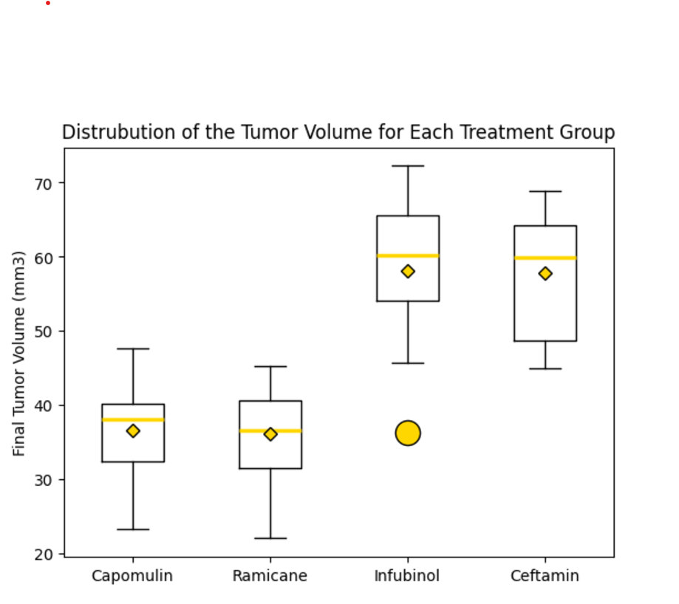

1. **Capomulin and Ramicane:**
   * These two groups show smaller boxes (indicating less variance) and a median line closer to the lower part of the box, suggesting they are the most effective treatments. Outliers may still exist, but overall, their distributions are concentrated in the lower tumor volume range.
2. **Ceftamin, Infubinol:**
   * These two groups show more variability in tumor volumes. The median line could be higher, indicating less consistent reduction in tumor volume.

**Conclusion:**

* Capomulin and Ramicane have the most favorable and consistent tumor volume distributions, with lower median values and fewer extreme outliers.
* This box plot offers a clear visual tool to understand the variability and effectiveness of each treatment group.

**Line and Scatter Plots:**

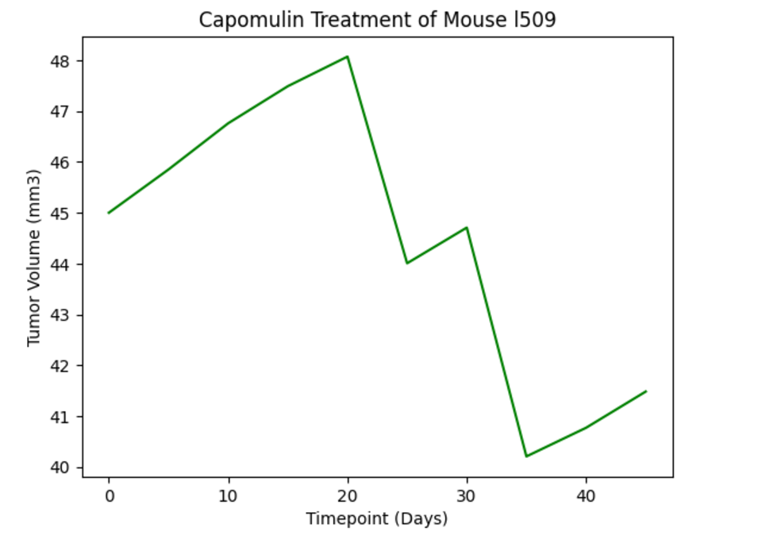

The line plot highlights that Capomulin is an effective treatment for tumor size reduction in the initial stages, as seen in the early decrease in tumor volume. However, the slight rebound towards the end suggests that the treatment may require adjustments to sustain its effectiveness over longer periods.

**Correlation and Regression:**

**Positive Correlation**:

* A **correlation of 0.84** indicates a strong positive relationship between the two variables. This means that, generally, as **mouse weight** increases, the **average tumor volume** also tends to increase.

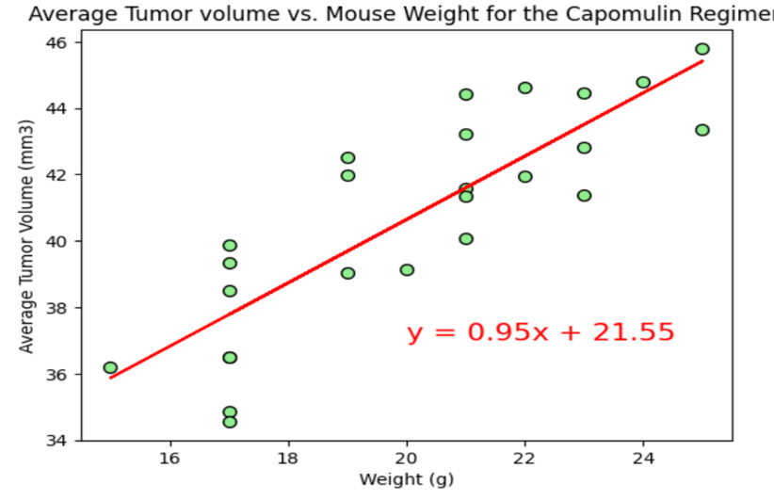

The linear regression model and the scatter plot help confirm the **strong positive relationship** between mouse weight and tumor volume in the **Capomulin** treatment group. Larger mice tend to have larger tumors, as expected from the correlation analysis.